**Wanted**: Create an application for coffee shop application that has onboarding page, home page, product details page and cart page.

**IMPORTANT NOTE:**

* **MAKE SURE THAT (VSCODE OR ANDROID STUDIO) AND FLUTTER ARE INSTALLED AND THEY ARE WORKING PROPERLY**
* **Make sure that the app is fully responsive.**

**Requirements:**

* The project must be created on **MVC design pattern**.
* You have to use **Getx state management.**

**Description:**

* **On Boarding**

Create the onboarding screen identical to the design and make the button navigate to the **HOME PAGE.**

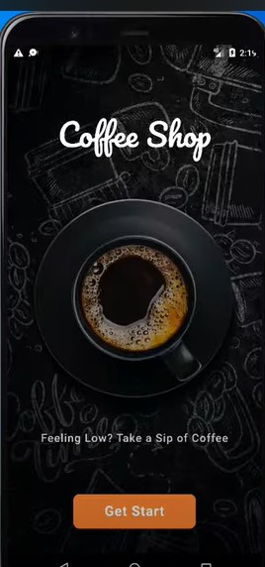

* **Home Page**

The Home page should have a **list of product items** that **the user can** **navigate** **to the details page of the product**. There should be a **Tab bars that can filter the product item**s. The bottom navigation bar should be working but doesn’t navigate to anything.

NOTE that you don’t need to make the add cart button in the item

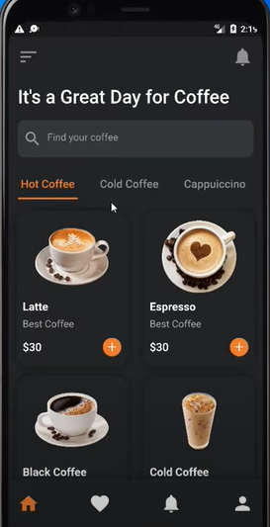

* **Product Details Page**

The product details page should have briefly description of the product and an **add to cart button that adds the item to the cart page**.

NOTE that you don’t have to make the quantity counter and the favorite button.

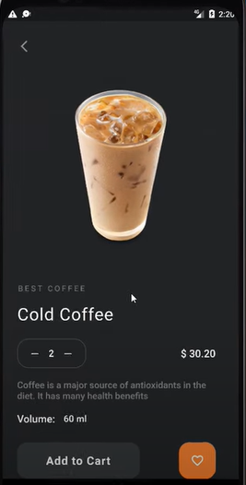

* **Cart page**

The cart page should have the items that the user has added from the Product Details page. the user can remove them or add more quantity of the item.

Note that you can create your own design in cart page